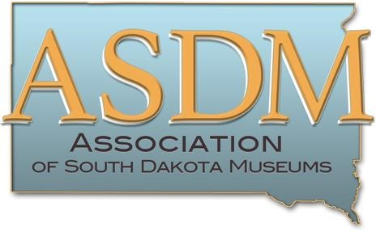

The Association of South Dakota Museums supports and acknowledges outstanding contributions to the museum field. Members of ASDM are invited to nominate individuals or museums for Excellence in Exhibits, Excellence in Leadership, or Excellence in Community Programming or Collaboration. Awards are only available to ASDM member museums, their staff, board members, and volunteers. Awardees will be acknowledged at ASDM’s annual meeting with a certificate, through media news releases, social media, and the ASDM newsletter and website. Only one award per category is given, and not all categories will necessarily be awarded. Please submit this nomination form along with supporting documentation: a 500-word essay; exhibition information if applicable; photos; and two support letters. Please submit materials in electronic format to: ASDM Awards Committee chair, Tawa Ducheneaux at tducheneaux@olc.edu. PDF and JPEG formats are preferred. Questions? Call (605) 455-6065. Deadline for the 2020 awards is October 1, 2020. Late or incomplete nominations will not be considered.
- The Excellence in Exhibits Award is awarded to museums for work in exhibition development during the past year. Nominations should include exhibit information and an explanation of the significance, success, and/or innovation of the exhibit.
- The Excellence in Leadership Award is given to individuals for work that exemplifies dedication and leadership in the South Dakota museum community during the past year. Nominations should outline the achievements and contributions of the nominee in relation to the South Dakota museum community.
- The Excellence in Community Programming or Collaboration Award is given to museums for work in the past year that reflects the spirit of community engagement. Nominations should highlight efforts that engage your community, create new audiences for the South Dakota museum community, or collaborate with community partners in an innovative and successful way. These projects could include but are not limited to interpretive exhibitions, lecture series, programming, or other community collaboration.
Your Name ________________________________________ Phone ________________________

Address ___________________________________________ Email ________________________

Your Institution ___________________________________________________________________

Nominee’s Name _________________________________________________________________

Nominee’s Institution and Title _______________________________________________________

Applying for: (mark one)

_____ Excellence in Exhibitions _____ Excellence in Leadership

_____ Excellence in Community Programming or Collaboration

APPLICATION DEADLINE: October 1, 2020

