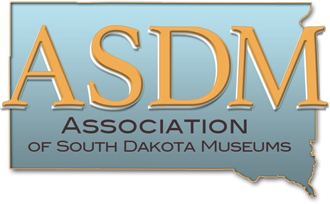

Award Nomination Form

The Association of South Dakota Museums supports and acknowledges outstanding contributions to the museum field. Members of ASDM are invited to nominate individuals or museums for the Excellence in Exhibits, Excellence in Leadership, or Excellence in Community Programming or Collaboration awards.
- The Excellence in Exhibits Award is awarded to museums for work in exhibitions during the past year. Nominations should include general exhibit information for the nominated exhibit and an explanation of the significance, success and/or innovation of the exhibit.
- The Excellence in Leadership Award is given to individuals for work that exemplifies dedication and leadership in the South Dakota museum field during the past year. Nominations should outline the achievements and contributions of the nominee in relation to the South Dakota museum community.
- The Excellence in Community Programming or Collaboration Award is given to museums for work in the past year that reflects the spirit of community engagement. Nominations should highlight efforts that engage your community, create new audiences for the South Dakota community, or collaborate with community partners in an innovative and successful way. These projects could include but are not limited to interpretive exhibitions, lecture series, programming, or community collaboration.

Awards are only available to ASDM members museums, their staff, board members, and volunteers. Award winners will be acknowledged at ASDM’s annual meeting, on social medial and on the ASDM website and newsletter. Only one award per year is given in each category and not all categories may be awarded every year.

Please submit this nomination form along with:
- A 500-word essay explaining the nomination.
- Exhibition materials if applicable.
- Photos illustrating or supporting the nomination, if applicable.
- Two support letters for the nomination.

Your Name ___________________________________________Phone ________________________

Your Institution______________________________________________________________________

Address____________________________________________Email___________________________

Nominee’s Name ____________________________________________________________________

Nominee’s Institution and Title __________________________________________________________

Award nominated for _________________________________________________________________
Submit nomination materials in electronic form to:Tawa Ducheneaux, ASDM Awards Chair
tducheneaux@olc.edu Questions? Call (605) 455-6065
PDF and JPEG formats are preferred

APPLICATION DEADLINE: APRIL 1, 2019

